**Fanka Shundovska**

**IntelliJ – JAVA Homework 5**

1. Create an array of type String with space for 5 String variables inside.

Read all the elements in an array (use while loop).

Print all elements.

String[] myStringArray = new String[5];  
int i = 0;  
while (i < myStringArray.length) {  
 myStringArray[i] = "Element " + (i + 1);  
 i++;  
}  
System.*out*.println("Elements in the array:");  
for (String element : myStringArray) {  
 System.*out*.println(element);  
}

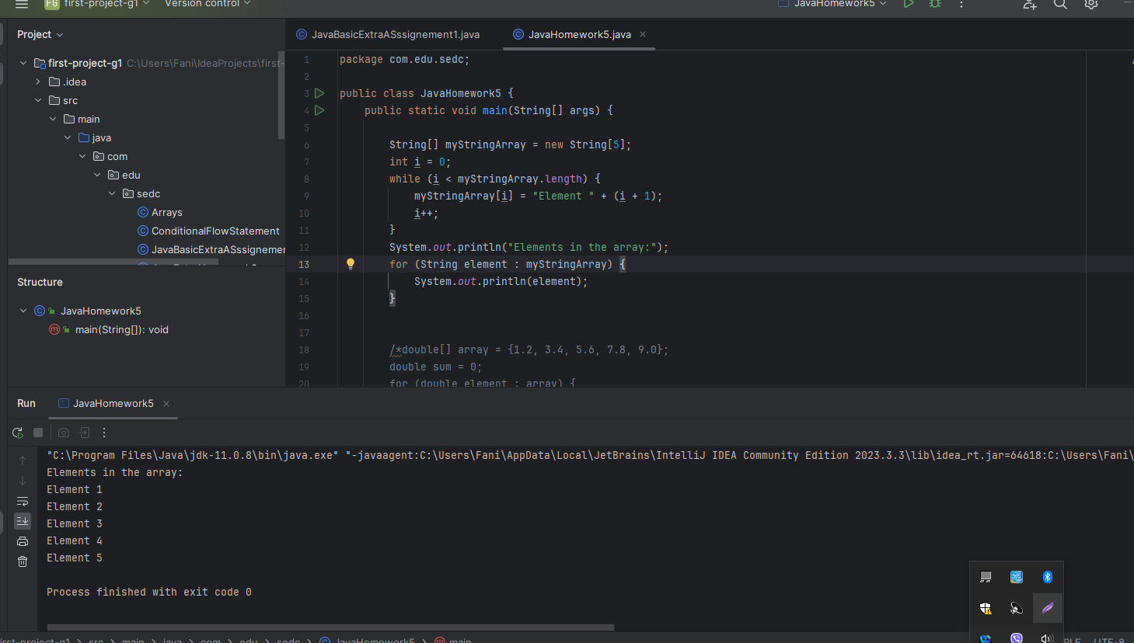

2. Create an array of five doubles and give each element some value. Calculate the sum of all the elements and print the result. Calculate the average of all of the elements and print that too.

double[] array = {1.2, 3.4, 5.6, 7.8, 9.0};  
double sum = 0;  
for (double element : array) {  
 sum += element;  
}  
double average = sum / array.length;  
System.*out*.println("The sum is: " + sum);  
System.*out*.println("The average is: " + average);

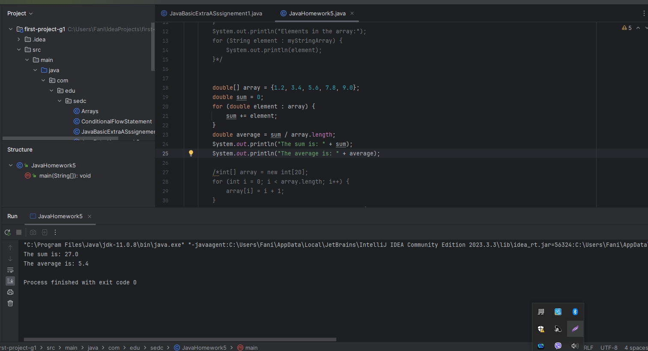

3. Populate an array with integers from 1 to 20. Print the contents of the array (the elements) backwards..

int[] array = new int[20];  
for (int i = 0; i < array.length; i++) {  
 array[i] = i + 1;  
}  
for (int i = array.length - 1; i >= 0; i--) {  
 System.*out*.println(array[i]);  
}

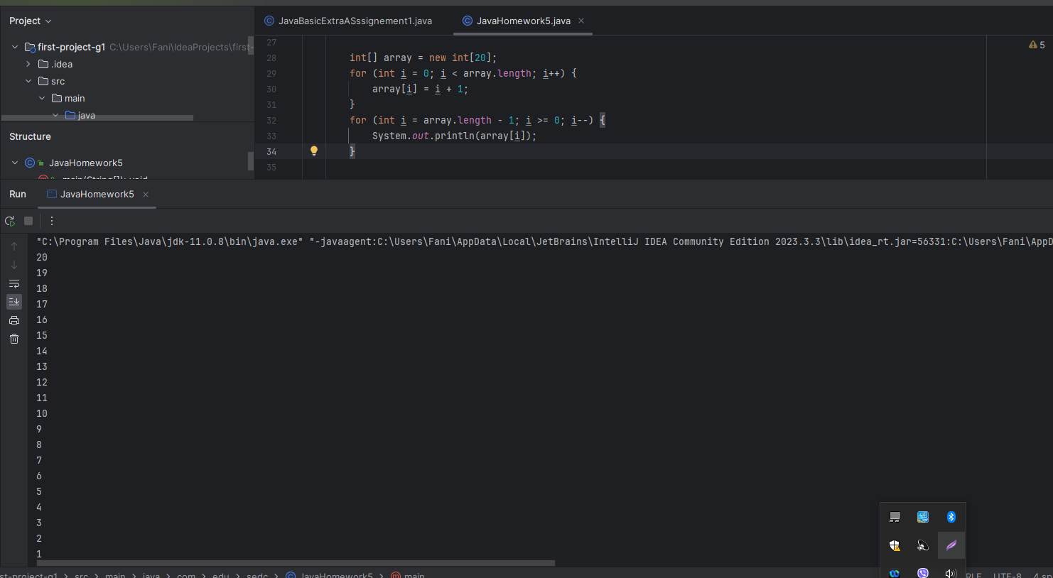

4. Use the array field provided below. Write a program that prints **how many elements that are odd numbers**.

int [] field = {2, 20, 3, 13, 15, 3, 9, 10, 1, 5, 8};

int [] field = {2, 20, 3, 13, 15, 3, 9, 10, 1, 5, 8};  
int oddCount = 0;  
for (int element : field) {  
 if (element % 2 != 0) {  
 oddCount++;  
 }  
}  
System.*out*.println("The number of odd elements in the array is: " + oddCount);

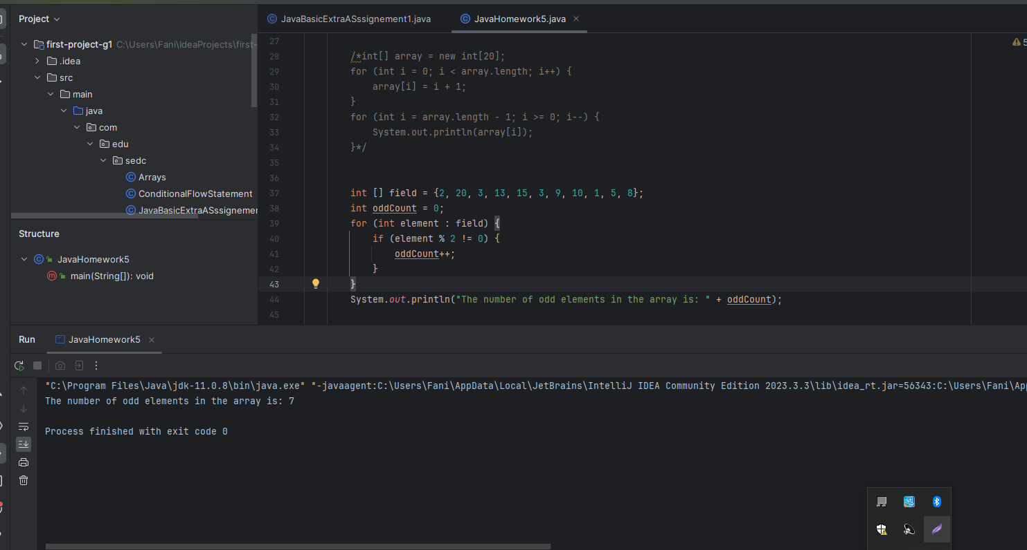

5. Write a java program to find the odd numbers in an array.

int[] myArray = {10, 21, 34, 45, 56}; // Example values  
  
System.*out*.println("Odd numbers in the given array are:");  
for (int i = 0; i < myArray.length; i++) {  
 if (myArray[i] % 2 != 0) {  
 System.*out*.println(myArray[i]);  
 }  
}

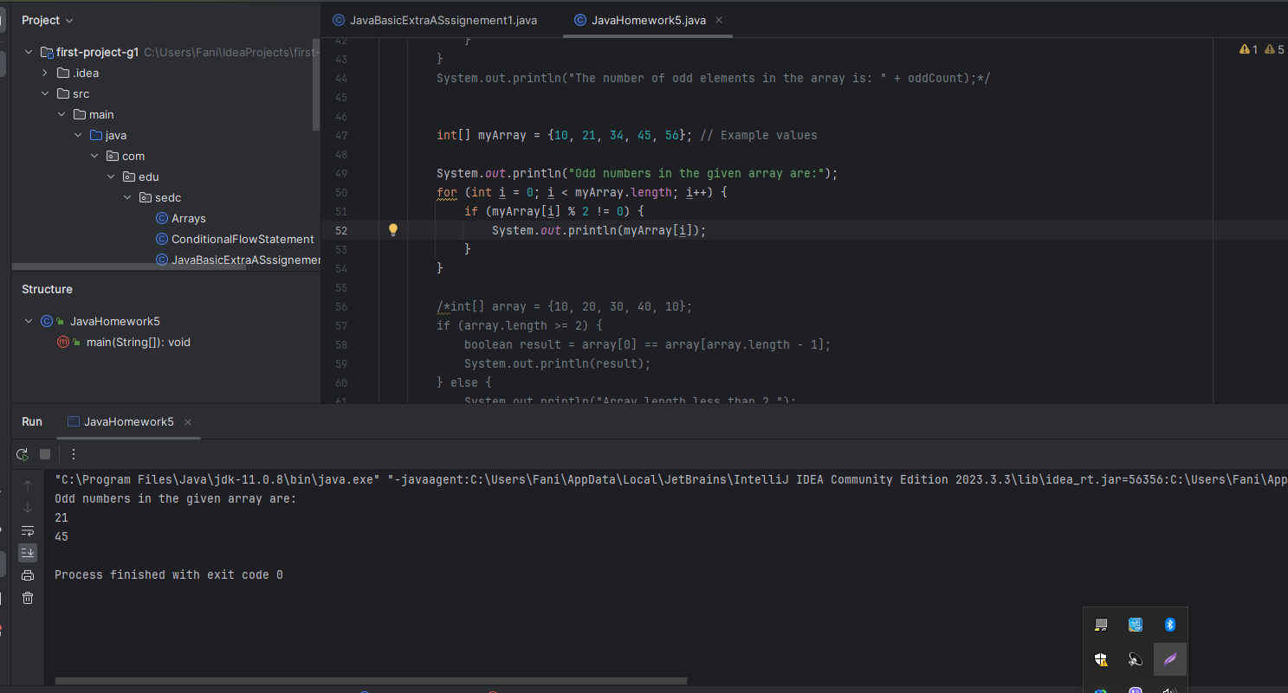

6. Write a program to check if the values of the first and the last element of the array are the same.

int[] array = {10, 20, 30, 40, 10};  
if (array.length >= 2) {  
 boolean result = array[0] == array[array.length - 1];  
 System.*out*.println(result);  
} else {  
 System.*out*.println("Array length less than 2.");  
}

